How to find cohesithy policy and run sql server database backups

1. On Cohesity main page search for the server name:

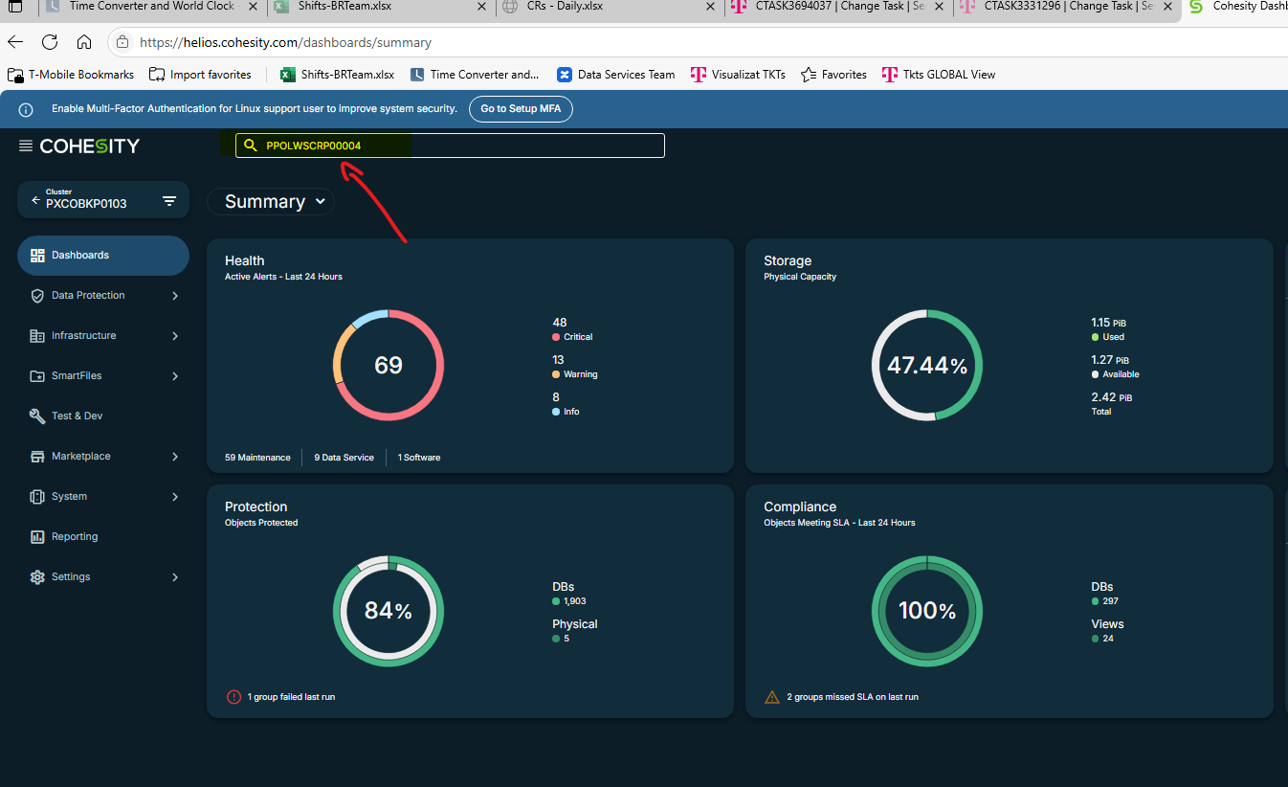

1. Click on the host name (the car with 3 weels 12)

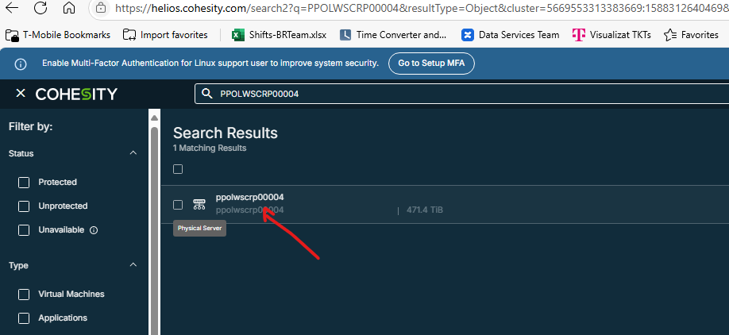

1. On the right side check the cluster name

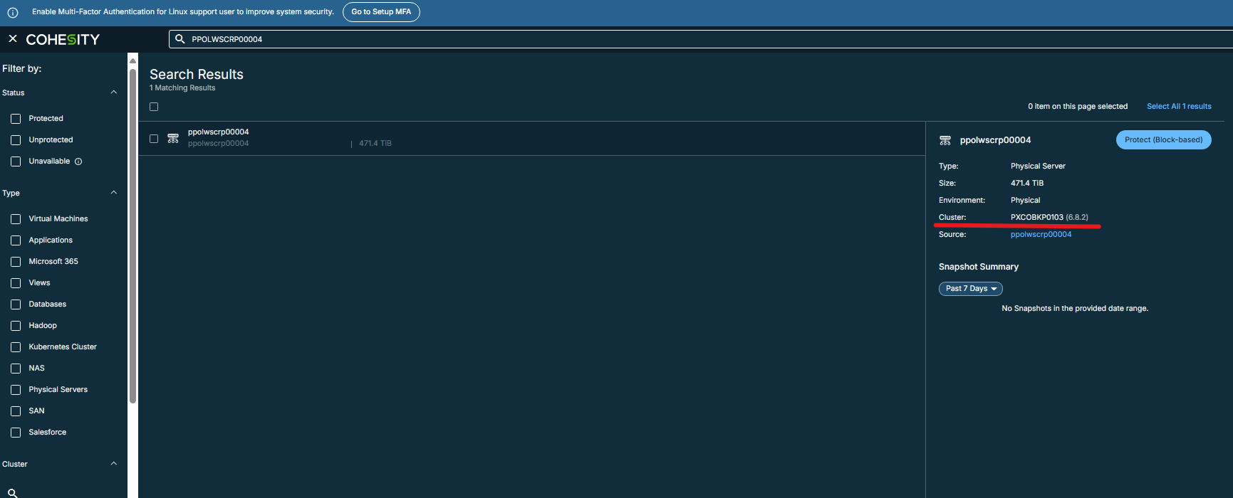

1. Go back to Cohesity main page and select the cluster name

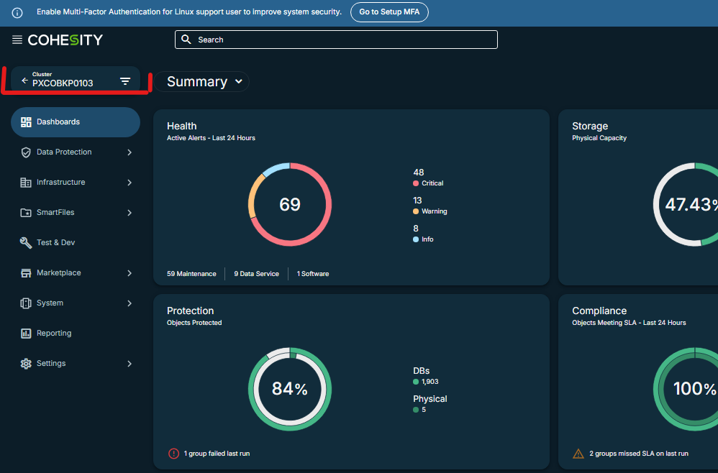

1. Click Data Protection and Protection

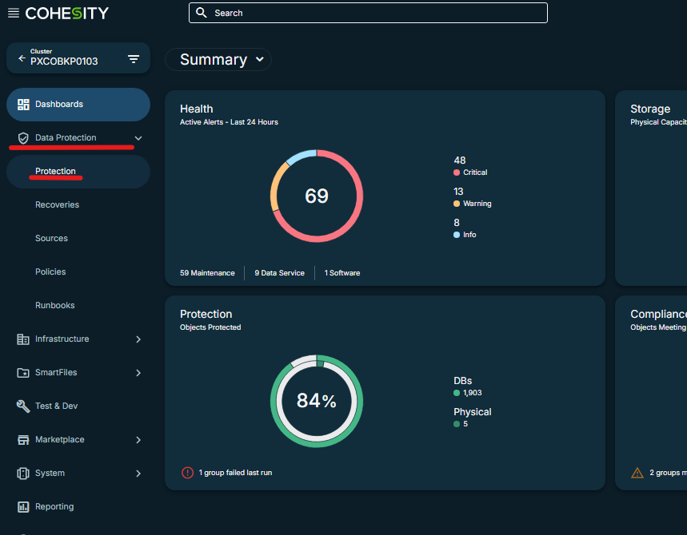

1. Put the server name on the ‘search group name” and wait for the refresh

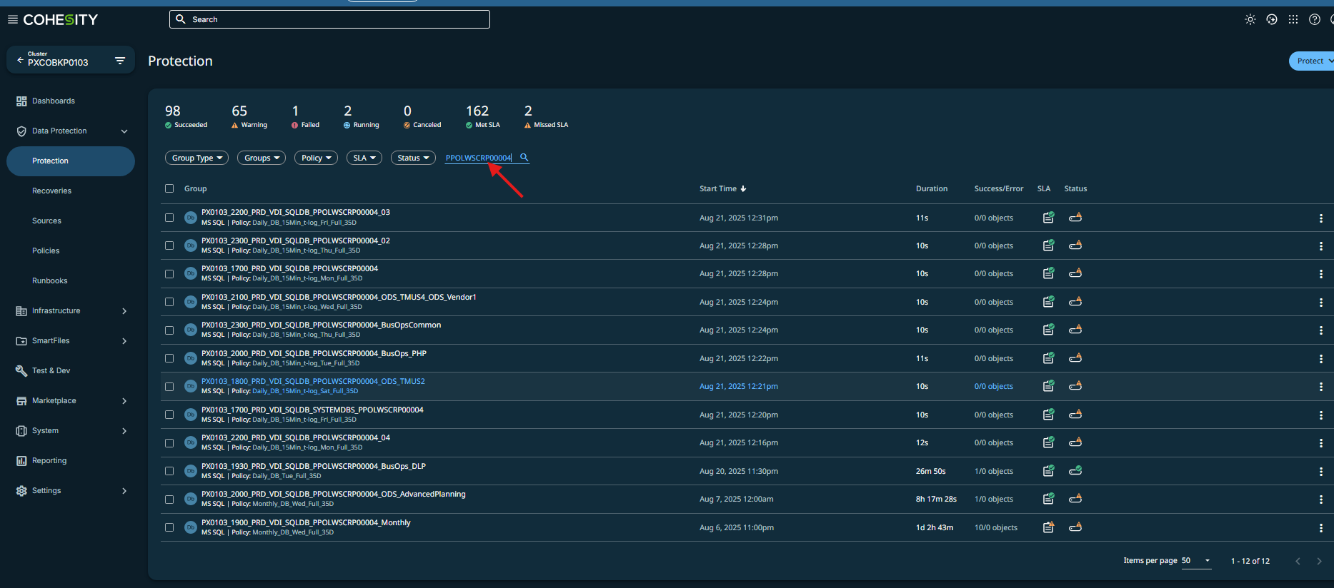

1. Click on the desired policy and on the right side, click on the 3 dots and select run now, then select the backup type you whant:

1. Click run now

1. Click on the olicy again to see the progress:

